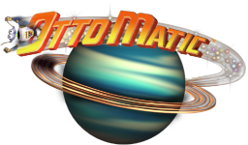

STRATEGY GUIDE

PLANET EARTH

LEVEL MAP
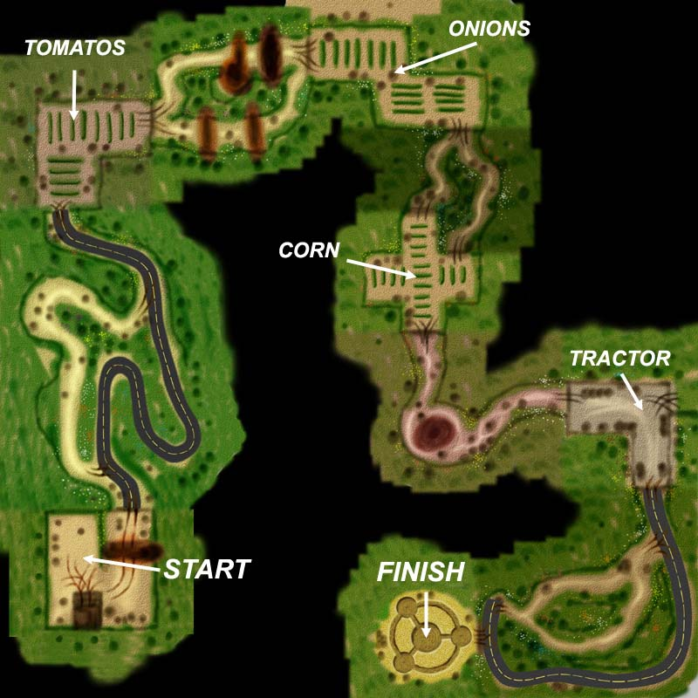

VEGETABLES
The Tomatoes, Onions, and Corn are all regenerating enemies. Notice that in those areas the alien saucer sometimes shoots a green beam instead of the usual one which it uses to abduct humans. The green beam is an irradiation beam which the saucer aims at the little sprouts growing on the ground. Those little sprouts will grow into new mutant veggies indefinitely.

THE TRACTOR & METAL GATE
Try as you may, it is impossible to destroy the evil tractor. It is also impossible to Jump-Jet through the Metal Gate there. The trick to this area is to lure the Tractor over to the metal gate and then get out of the way before he slams into you. If you can get the Tractor to smash the metal gate down, then gate will be gone and the Tractor will deactivate.

PLANET SNOTH

LEVEL MAP
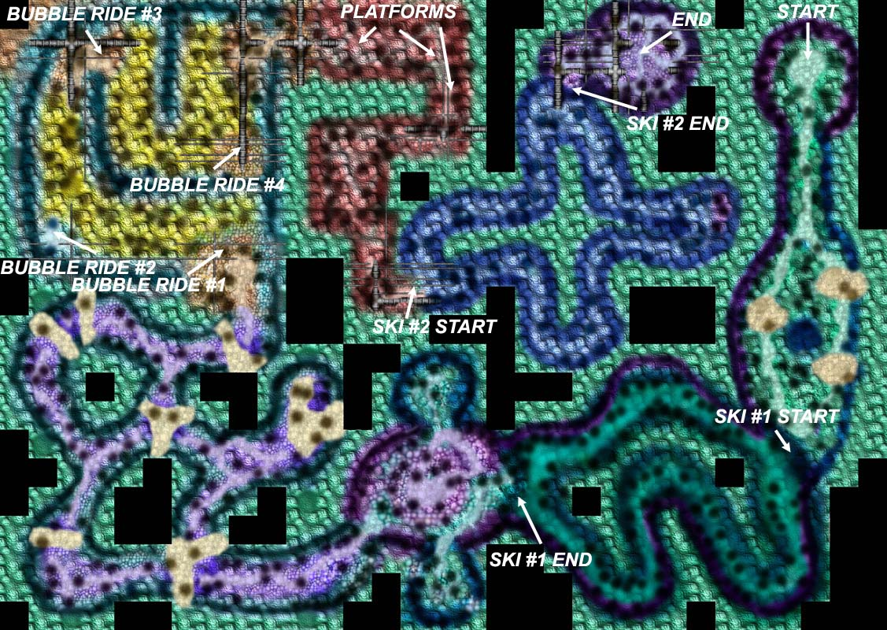

GENERAL NOTES
Even though this is only the second level in Otto Matic, it is probably the hardest. What makes it so hard is mainly the length of the level since it is the largest of all of the levels in the game. There are arrows places around the terrain to help guide you on the path. If you follow these arrows it will make the level twice as easy.
When you get to your rocket at the end of the level, something different happens. Instead of boarding the rocket like in the other levels, here you get sucked down into the planet's core. The visual here is confusing to many people, but rest assured that when you see Otto squirming and being sucked under, that's a GOOD thing. The next level takes place in the core of Planet Snoth.

FREEZING ENEMIES
The primary weapon on this planet is the Freeze Gun. Here, when you shoot an enemy with the freeze gun it will stay frozen for several seconds before it either thaws out, or the enemy cracks the ice. When an enemy is frozen, just give it a solid punch to shatter it. When you shatter a frozen Slime Enemy it will explode into several smaller slime blobs which will then thaw. But if you gather the small blobules before they thaw, you will get powerups according to the color.

SKIING
There are two skiing areas on this planet. You pick up the magnet powerup which will attract you to the metal dragon and that gets you going. On both skiing tracks, you will go around the course TWO times. On the second pass, the metal dragon will go close enough to the exit zone for you to hop off. If you miss it, then you've got to keep skiing for two more laps until the dragon goes by the exit again.
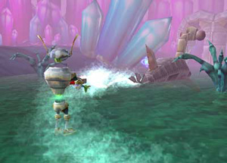

BUBBLE RIDING
The soap bubbles are created by touching the bubble pump mechanism. A single bubble is created each time you activate the mechanism, and you'll have a few seconds to jump up into the bubble. Once in the bubble you have a limited time to cross the sea of liquid soap and reach the next safe area. Avoid the pointy shrubs and anything else that is solid since it will pop your bubble.
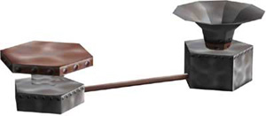

PLATFORM HOPPING
Another way to cross some areas of the soap lake is to hop across the big and small platforms. Sometimes, you will have to Jump-Jet to get to the platforms, but other times you can simply jump from one to the next.
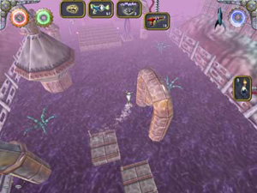
One note about platform jumping: We've noticed that the MacAlly keyboards are very difficult to use with this game because they keys are so spongy. The spongy keys make the jumping very difficult on this level. Your results may vary, but we recommend using a more responsive keyboard to play this game.

PLANET SNOTH - SLIME BOSS

LEVEL MAP
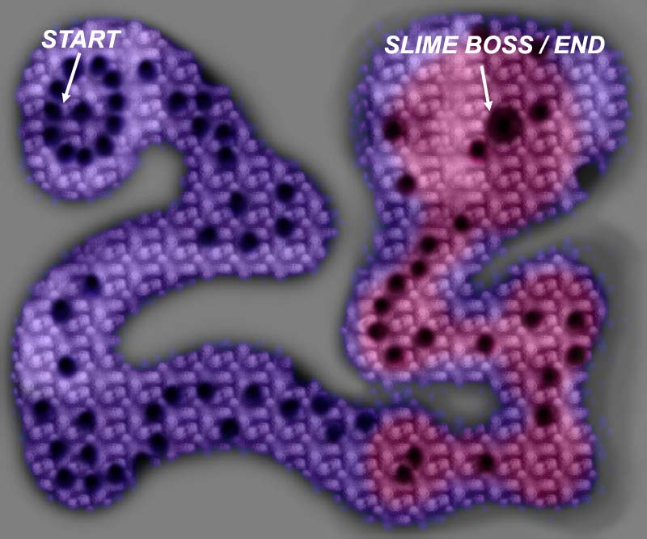

GENERAL TIPS
This level takes place in the bowels of planet Snoth's core where the giant slime machine resides. You cannot touch the toxic slime which is all around you. You must remain on the platforms since falling onto the slime will cause great damage. With full health, Otto can survive 3 bounces off of the slime, but be careful, sometimes Otto will get stuck underneath a platform if he falls off and he won't be able to bounce back up.
The gravity on this level is much lower than normal since you are in the center of the planet. As a result, Otto can jump higher and farther. Odds are that you will have a good supply of Jump-Jet fuel when you arrive at this level. Keep that in mind when hopping across the platforms because you can get through this level much faster and safer if you use your jump-jet to cross some of the complex areas.

THE SLIME MACHINE
At the end of this level is the Giant Slime Machine which you must destroy. It is guarded by plasma beams and ooze guns. Destroying the machine is fairly simple. First, just blast away the four plasma beam emitters which surround the central unit. Once you do this, the central unit will begins to open and close. Each time the dome opens, it will shoot harmful ooze at you. Shoot the ooze tubes to destroy them. Finally, when the ooze tubes are gone, blast the central slime tube to destroy the machine.
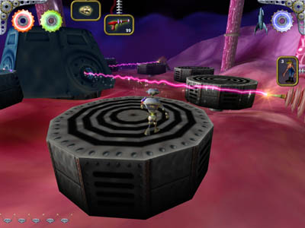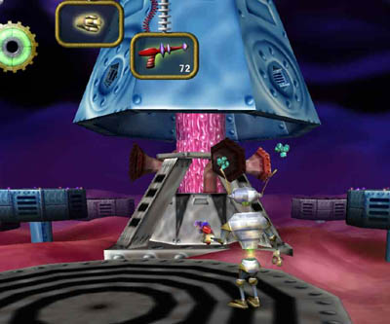

PLANET KNARR

LEVEL MAP
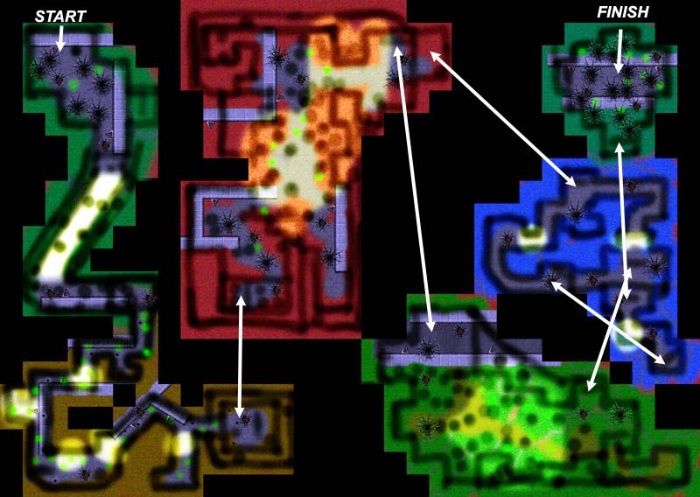

GENERAL NOTES
Planet Knarr is probably the most intense level in Otto Matic. Lots of action, explosions, and effects. They key to this level is to just keep moving and don't do any sight seeing.

CRUNCH DOORS
The Crunch Doors are activated by zapping them with a Supernova weapon. These doors are one-way which means that they can only be activated from one side. The side with the rivets is the active side:
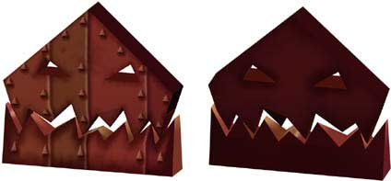
Trying to activate one of these doors from the other side will have no effect. Once a door is activated it will remain activated indefinitely.

TELEPORTERS
The teleporters are also activated by using a Supernova, and they will remain active indefinitely. There are 12 different teleporter pairs in this level, and they are identified by the symbols on their consoles. The symbol indicates where the teleporter will take you. Generally speaking, each teleporter will take you to a different colored areas as seen in the map above. As a rule of thumb you should always activate and use any inactive teleporter since it will generally advance you through the level. Toward the end of the level there are some teleporters which may take you back to an area that you've already seen.
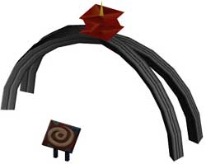
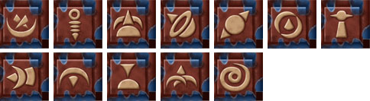

ZIP-LINES
Press jump to get onto the zip line pulley. Once on, you cannot get off until the zip-line ride is completed. If you get hurt on the zip-line and fall off, just wait a few seconds and the pulley will reset itself so you can try again.

PLANET RENNIE

LEVEL MAP
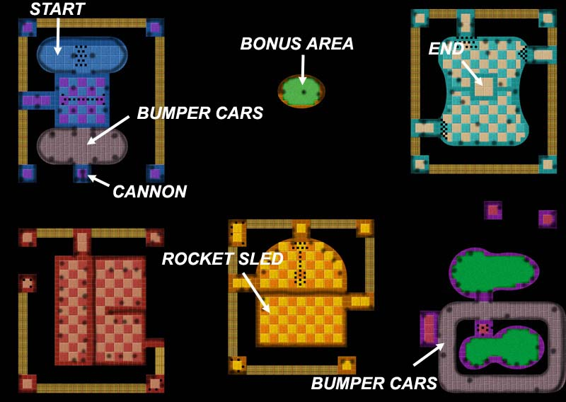

BALLOONS
The balloons contain powerups. Most weapon can pop the balloons except for the Ray Gun. The Ray Gun blasts will simply ricochet off of the balloon. The best weapon for popping balloons is the Dart since that weapon will home in on the balloons.

GENERAL TIPS
This is probably the easiest level in the game. It takes a while to complete simply because there are many tasks to perform, but about the only way to actually get killed on this level is to accidentally fall off the edge of the scaffolding or through a trap door. So, just take your time and don't be too hasty when hopping across the clouds, and keep an eye out for the trap doors.

BUMPER CARS
You cannot be hurt or killed while riding a bumper car, but the metal flooring that the cars ride on is electrified, so if Otto steps on it, he'll be electrocuted. To get into the bumper car you need to hop onto the strip of tires which separate the normal floor from the electric floor. Then just hop on top of the bumper car to enter it.
There is a force field blocking the exit to the bumper car area, and the way you deactivate it is to knock out the power poles which surround the bumper car arena. Each pole has a pink, undulating bumper at it's base. You need to ram this bumper at full speed to burst it. Then you need to ram the pole at full speed to knock it out. In other words, you have to ram each pole twice: once to burst the bumper and another time to deactivate the pole. You'll know that a pole is deactivated when the glowing light at the top goes dim. When all of the poles in the arena have been knocked out, the bumper cars will turn off, the floor will no longer be electrified, and the force field at the exit will be gone.
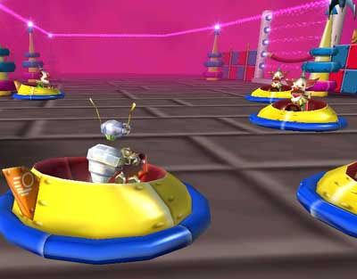

THE CANNON
The cannon is used to blast Otto across the long abyss between the first and second area of this level. To enter and activate the cannon, simply jump on top of the barrel in front of the cannon and then walk to the cannon's opening. Press the Jump key to enter the cannon and the rest is automatic.
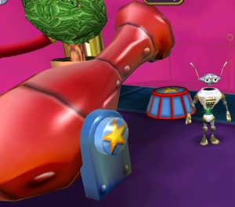

PLANET SULAK

LEVEL MAP
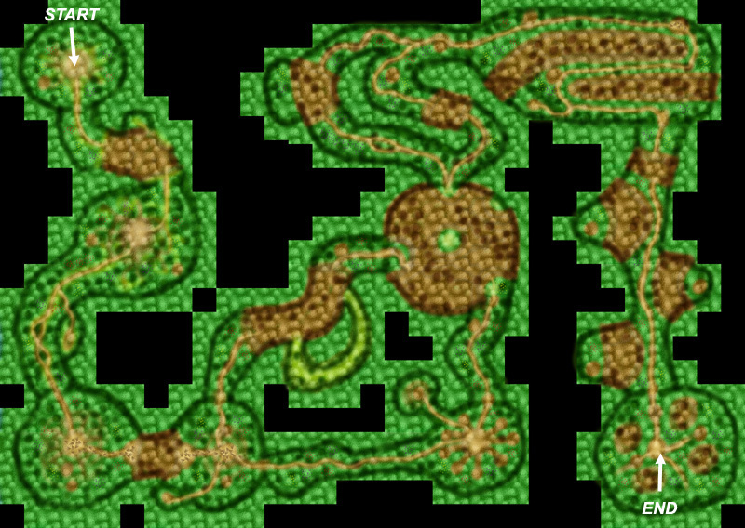

HUTS
The bamboo huts which you see around the planet are smashable when Otto is giant. Just walk into the hut to destroy it. Inside many of the huts are powerup pods.

GROWTH POTION
The only way to smash through the giant wooden gates on planet Sulak is to become a giant by drinking the vial of growth potion. Once you're a giant, you can either Jump-Jet through the door, or you can punch the door to smash it. Also, any of the enemies on this planet can only be killed when you are a giant. The Giant Lizard and the Venus Flytraps can only be killed when you are a giant, and the Flame Thrower weapon is the weapon of choice on them. The praying mantis can be killed when you are small, but when you are a giant they are much easier to kill.

HIDDEN ROOMS
The growth potion vials are almost always hidden in small secret rooms which are off the sides of the main path. The dirt path will lead you to these hidden rooms, so if you get to a giant wooden gate and you need a growth powerup, then back-track along the dirt path and look for branches which lead to the hidden room.

PLANET SULAK - PITCHER PLANT BOSS

LEVEL MAP
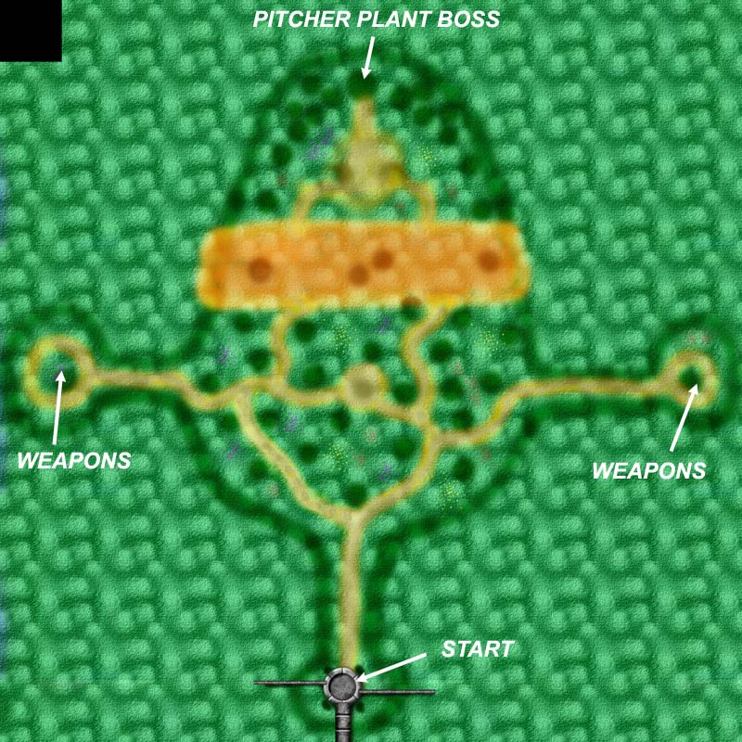

FIGHTING THE BOSS
The pitcher plant boss is composed of 3 parts: The tentacles, the pitcher pods, and the main pitcher plant.
The tentacles come from the giant artichokes on the sides of the boss. Several shots with the flame gun will burn the artichokes and they won't be able to generate tentacles. Shooting the tentacles themselves will have no effect. Destroying the giant artichokes may help you, but it is not a necessary step in defeating the pitcher plant boss.
Also on the sides are the pitcher pods which shoot deadly pollen spores at Otto. A few shots with the flame gun destroy these as well. Once all of the pods are destroyed the main pitcher plant will come to life and begin attacking.
The pitcher plant is only vulnerable when his mouth is open. Hop between the two tallest leaf platforms and fire into his mouth, just one shot with the flame gun right as his mouth opens. Shooting multiple shots is just wasting ammo. As you shoot him, he will begin to darken and will eventually blow up.
Once the Pitcher Plant is destroyed, the tractor beam holding your rocket will be deactivated and you are free to leave.
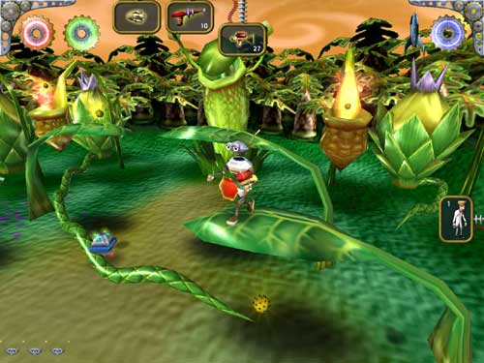

PLANET DENIZ

LEVEL MAP
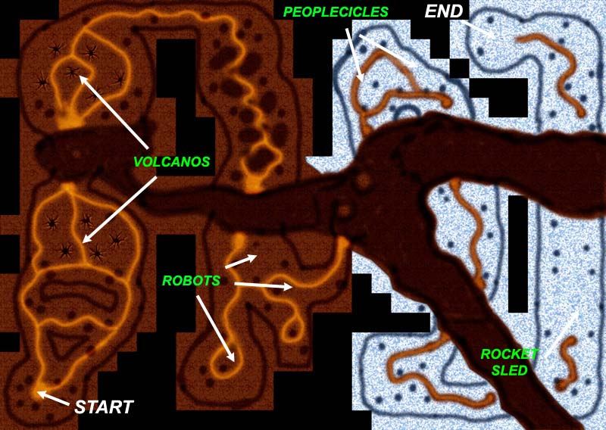

GENERAL INFO
This is a very straight-forward level which is relatively easy. It is mainly a level to score lots of points on by rescuing humans and collectings lots of weaponry.

FLAMESTER ENEMY
The Flamester enemy can only be killed by shooting him with the Freeze Gun. Each shot of the freeze gun will shrink him down. Shooting him with an energy weapon such as the Flame Thrower will actually make him bigger and stronger.

ICE ENEMY
The Ice Enemy is the opposite of Flamester. Shooting the Ice Enemy with the Freeze Gun will make him bigger and stronger, but shooting him with the Flame Thrower will melt him and make him smaller.

PEOPLECICLES
In the ice areas of this planet there are humans frozen in ice - Peoplecicles. To free and rescue these humans you must first shatter the ice by shooting it with an energy weapon. Then the human will be freed and you can tag him like always.

ICE SAUCER
There is no Exit Rocket on this level. Instead, you escape the planet in an alien saucer which is buried under the ice. In order to get to the saucer you must shatter the ice sheet which is covering it. To do that, lure one of the Hammer-Bots over to the ice and run in front of it to get it to swing at you. Every time the Hammer-Bot misses Otto and hits the ice sheet, it will crack the ice a little. It takes 4 hits on the ice to shatter it. Then the saucer's hatch will open and you can jump and take off.
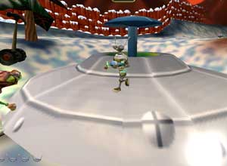

PLANET SHEBANEK

LEVEL MAP
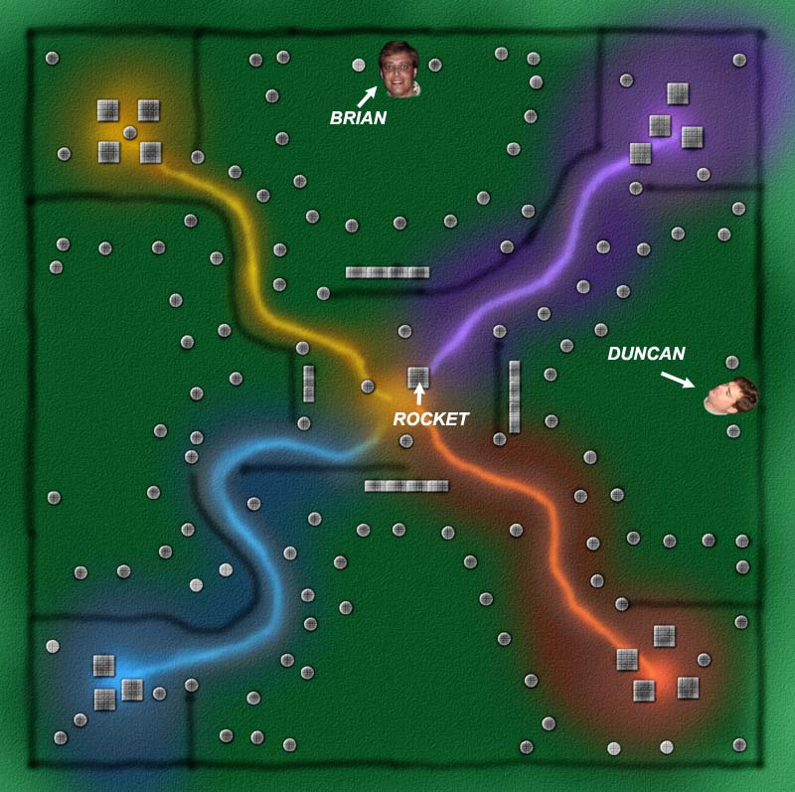

SAUCER BEAMS
Using your saucer which you commandeered on the previous level, you must try to free as many humans from the POW Camp as you can. The saucer has two types of beams: the Destructo-Beam and the Abduction-Beam. Use the red Destructo-Beam to blow up just about anything on the ground, but mainly you want to blow up the huts where the humans are being kept. Blowing up a hut will free the humans. Once you are ready to gather the humans you have freed, you need to switch to the Abduction-Beam which is the white beam. Activate it, and then start vacuuming up as many humans as you can. The saucer can hold a maximum of 10 humans at a time.

THE ROCKET
When you have some humans you would like to save, fly over to the rocket ship and the computer will take over when you are close enough. The humans will be beamed down and they will run into your rocket. Each saved human will give you a little bit of rocket fuel. It takes at least 20 humans to get enough fuel to leave, but you can keep resucing humans for as long as you like to get more points before leaving.

THE GUN TURRETS
The moving and stationary vertical beams are deadly to the saucer, but they are fairly easy to avoid. The Gun Turrets, however, are tough. The strategy with them is to sneak up behind them, get a running start with your Destructo-Beam activated, and then plow them over. A good player should be able to complete this level with only being hit a few times by a turret shot.

THE HEADS
No, zapping our heads which we've drawn into the terrain does not get you bonus points! They're just there for fun.

PLANET X

LEVEL MAP
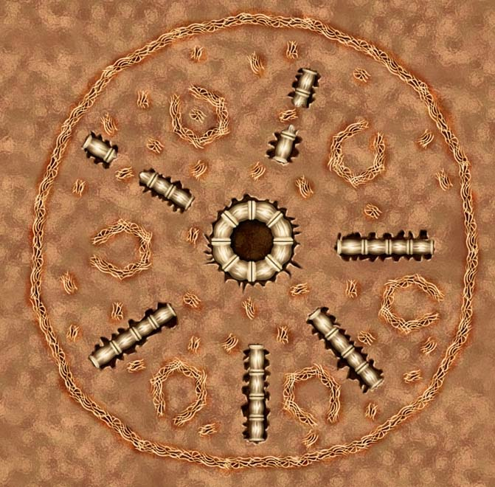

ELITE BRAIN ALIENS
Guarding the Giant Brain Boss are the Elite Brain Aliens who wear red capes, unlike the regular green Brain Aliens. These guys are ruthless and are very aggressive. You cannot outrun an Elite - they will simply keep following you, and they run pretty fast. The Elites come from the portals which surround the Giant Brain, so to eradicate them you must start by destroying their portals.
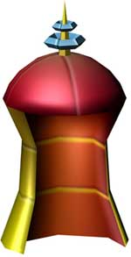
The best strategy for winning this level is to first gather as much weaponry as you can. Then run over to the Elite portals and fire like crazy. Run in a circle around the Giant Brain blasting all of the portals. Using this method you can quickly eliminate all the portals and thus the Elite's ability to keep reappearing.

REGENERATING WEAPONRY
Because of the massive amount of firepower needed to defeat the Giant Brain and the Elite Brain Aliens, all of the powerups on this level are regenerating, so you don't need to worry about running out.

THE GIANT BRAIN
The Giant Brain will activate as soon as you destroy all of the Elite portals. The Giant Brain is vulnerable to all types of weapons and attacks, but only when his brain halves are open. When the halves are apart, shoot like crazy to damage him. As he is damaged he will turn red. When the Giant Brain is finally blown up, gather all the rocket fuel atoms that you can and then escape in the rocket. You cannot enter the rocket until the Giant Brain is destroyed.

